ENROLMENT FOR SACRAMENTAL PREPARATION 2025
CONFIRMATION and FIRST EUCHARIST
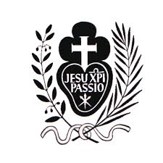
Child’s Name __________________________________________________
Date of birth ______________________ Age: _______________________
Address __________________________________________________
______________________________Postcode_____________
Contact Phone No. _______________________ Mobile No. __________________
Email __________________________________________________
Please tick if you would like to receive the Parish Bulletin electronically 
Sacraments already received (Please Tick)
Baptism Reconciliation
Confirmation First Communion
Parents’ Names _______________________________________________________
School attending: ____________________________________ Yr level: _______
Please return to the Parish Office or email to sue.schulz@themonastery.net.au by MONDAY 2nd of June
Payment of $50 received __________________________________(Office use only)
NB: If your child was NOT baptised in St Paul of the Cross Parish (either St Paul’s or St Raphael’s) or received First Reconciliation please enclose a copy of your child’s Baptism certificate.

